Vocabulary Four Square Pixlr Directions

PREP: Think about your vocabulary word. Read the definition of the word provided by a dictionary. Now, paraphrase the definition. Check with a peer to make sure that your definition is still accurate. Practice using the word. Come up with three sentences that use the word. Remember your favorite.

SEARCH: Search Google Images for pictures that represent your word. Make sure to copy and paste the url into a Word document so you can use it later. Download 3 pictures that represent your vocabulary word. See the rubric below for guidelines on choosing a picture.

APP: Create a four-square visual representation of your word using Pixlr.com. Look on my website (zappiaslanguagearts.weebly.com) for a tutorial showing you how.

Vocabulary Four Square Pixlr Directions and Rubric (5 points total)

This box contains a picture or symbol that represents the vocabulary word in the context it’s used in PEAK. (+1/2) | The word or term is on the top of the text area. It should be spelled correctly and the part of speech should be labeled. (+1)  Here, definition is given providing the different contexts the word can be used in. (+1)  Include a sentence in which the vocabulary word is used. If possible. A picture should go along with the sentence. (+1)  List the URLs you used here.  Created by _______________ and ___________________  (no last names!) (+1/2)
This box contains a picture or symbol that represents the word being used in a different context. (+1/2)

This box contains a picture or symbol that illustrates the sentence that uses the vocabulary word. (+1/2)

Example:

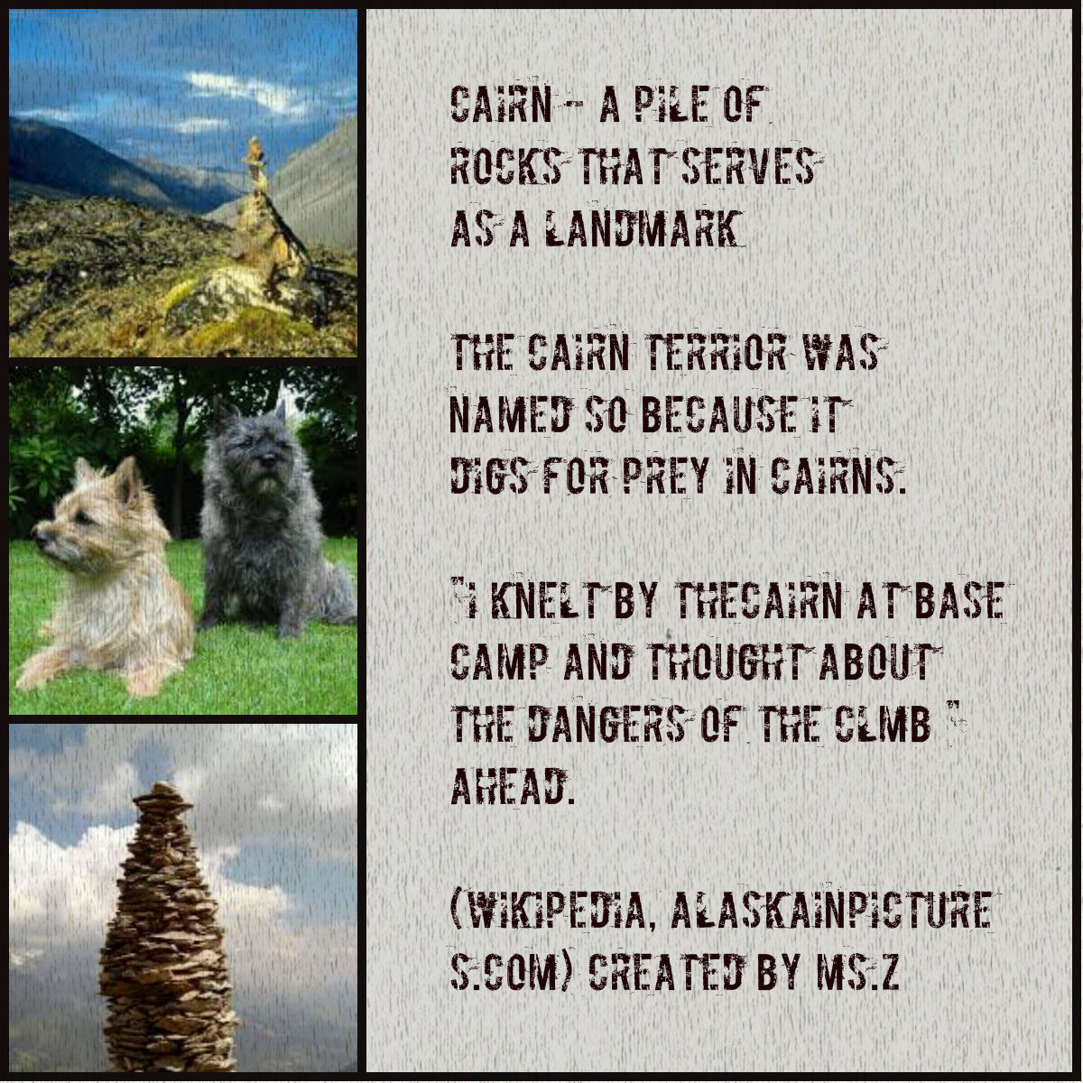
Save your photo collage to your student folder on the computer or your flash drive. Then, email it to your language arts teacher.

The subject line should say: vocab four square (and then your specific vocabulary word)
Vocab Four Square: Cairn

Ms. Zappia : jzappia@wcpss.net

