Quarter 1, List 3 Vocabulary Practice

Using the answer line provided, complete each item below with the correct word from the box. You will use each word only once.

Pompous Belligerent Convalesce Grimace Irony Ascertain

1. The man at the grocery store was ________________ toward the cashier when he would not let him use his recently expired coupons.

2. As Suzy hesitantly approached the haunted house, she ________________(d) at all the bloody Halloween decorations surrounding her.

3. The 6th grader students acted quite ________________ whenever they were in the presence of the first graders on the bus.

4. The football player had to ________________ from his injuries after last night’s nail biting game.

5. I paid to ride the Ferris wheel at the carnival, when suddenly, my mom ran up to me with three free ride passes. She laughed at the _____________ of the situation.

6. Lilly had to ________________ the whereabouts of her other polka-dot sock.

Please fill out the Four-Square Models below.
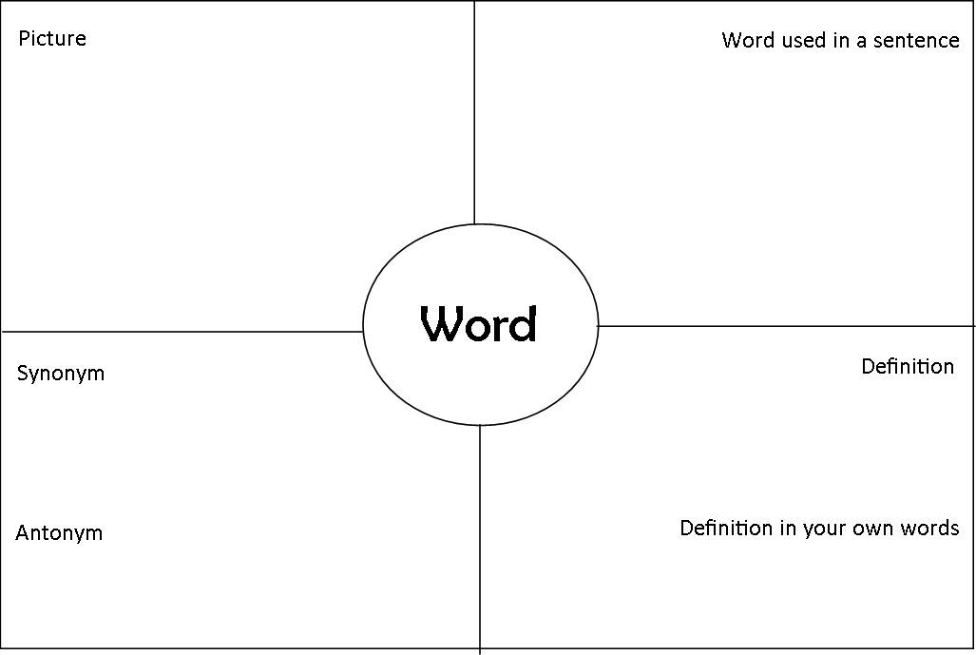
Lucrative
Stagnant
Ominous
Heathen

